Project team 10 - RESTAURANT AUTOMATION SYSTEM

# Project Scope and Objectives

The aim of this project is to design, build and test a RESTURANT AUTOMATION SYSTEM which can handle the ordering process; in particular the flow and storage of order information.

This is a complex software development project which approximately will take four months to complete. The project will be split up into stages and documented thoroughly throughout.

Project management is the key factor as far as sticking to the overall scope of the project is concerned. It is also of paramount importance that tried and tested practices and techniques from various fields are adhered in order to ensure that no common development project mistakes are reproduced.

Restaurant Automation System (RAS)" is an **application** to restaurant management. The services that it facilitates are food ordering, reservation table management, customer, waiter and chef information management.

Our main objective is to build a working software system which can handle the ordering process; in particular the flow and storage of order information. In a restaurant, the traditional hand-waving method for calling services is inefficient which often leads to many complaints and confusions. With this system, ordering and making reservations will become convenient and systematic in order to replace traditional way of jotting down the details on a piece of paper.

A data processing unit allows the administrator to keep a track of progress and status of employees and restaurant functions. It facilitates a computerized system to help restaurant personnel coordinate their activities, improve their services, and also for the management to track business growth and create future plans.

**Objectives in a gist**

**Important features**

* A means to persist data across each interface
* Interface for displaying pending orders
* Interface for managing menus, menu items and ingredients
* Interface for reservations
* Payment options
* Interface for Table management
* Feedback from customers

**Optional features – Future Scope**

* Customer interface is capable of running on a variety of different handheld devices
* Management interface can be accessed over the Internet
* Manager can view past orders in the form of graphs
* Automatic deductions of stock levels upon order submission
* Manager can administer the waiters
* Customer interface can provide alerts when orders have been completed

# Project Environment

Whether you are working on LAN projects or Distributed projects, there are two sides of it:-

Front End

Back End

Front End remains on client side. Front end is made for end user who uses our application. Basically in front end, our input-output forms reside which takes the input from the client and gives output back to client.

Back End remains on server side and has two components namely server side programs and database.

The proposed system uses Java as front-end and MySQL as back-end tool. MySQL is a popular tool used to design and develop database objects such as table views, indexes. Also we made connectivity JDBC.

The above tools are readily available, easy to work with and widely used for developing commercial application.

The software like MySQL Workbench 6.3, Net-beans IDE 8.1, JDK, JSDK, J2EE,JSWING and operating system WINDOWS-8 used were already installed on the existing computer system. Also we made use of external API’s such as Java mail for email functionality after successful registration of customer and rs2XML API for display of tables. Since we made use of open source technologies hence there was no need to purchase external software which makes it technically feasible.

Java is a high-level, third-generation programming language like C, FORTRAN, Perl and many others. It is a platform for distributed computing – a development and run-time environment that contains built-in support for many applications. One of the most important features of Java is platform independence, which makes it famous and suitable language for most applications these days.

The system requires MySQL as a database; however the system will be ODBC complaint to work on any standard database. We made use of MySQL as it is open-source, provides clarity in separation of designing and coding, secure, scalable, and reliable and also supports RDBMS concepts. Data Base is a collection of tables and table is a collection of records in a tabular form i.e. in row and columns format. Data Base can be divided into two parts:-

1) RDBMS

2) DBMS

We will be using RDBMS (Relational Database Management System) in our project

The other Development Environment that we used in our project were Windows 8 Operating system, JavaBeans (JB) as a business logic software, and also JavaScript for all the Client side validations. Client side JavaScript is designed to reside inside HTML document & ensure they run properly.

## Software Requirements

## SPRINT 1

**Story** RAS_Manager_US_01

**Description**:

As a Manager, I want to view the order placed by customer so that I am updated about the current situations/scenarios in the restaurant

**Acceptance criteria**:

**Given**: Manager is logged in successfully

**When**: Manager clicks on Orders tab

**Then**: System should display all the list of orders placed for each table

**Tasks**:

1. Group UI elements that appear on all pages after manager logins into common Vertical Menu and Header elements - 2 HrsCreate Order table in Database - 4 Hrs
2. Code and test UI for Order page - 8 Hrs
3. Code and test Database query for Order result page - 10 Hrs
4. Code and test Order class - 3 Hrs
5. Code and test controller for Order result page - 1 Hrs
6. Peer Review of Code - 2 Hrs
7. Code acceptance tests for Order page -2 Hrs

## SPRINT 1

**Story** RAS_Manager_US_02

**Description:**

As a Manager, I want to view the menu items so that I get to know what is being served in the restaurant

**Acceptance criteria:**

**Given**: The manager/administrator has successfully logged into the system

**When**: The manager/administrator clicks on the menu item

**Then**: Systems displays the menu

**Given**: The manager/administrator has successfully logged into the system

**When**: System is under maintenance and manager clicks on menu option

**Then**: System displays “menu not available”

**Tasks:**

1. Create Menu table in Database - 2 Hrs
2. Code and test UI for Menu page - 8 Hrs
3. Code and test Database query for Menu result page - 6 Hrs
4. Code and test Menu class - 5 Hrs
5. Code and test controller for Menu result page - 1 Hrs
6. Peer Review of Code - 2 Hrs
7. Code acceptance tests for Menu page - 2 Hrs

**SPRINT 1**

**Story** RAS_Chef_US_02

**Description:**

As a Chef, I want to edit the menu items so that I can add daily Chef Specialties

**Acceptance criteria:**

**Given**: Chef is logged in successfully

**When**: Chef clicks on the Menu tab

**Then**: System should display the available list of items with edit button for individual item and Add Menu/ Speciality and Delete buttons

**Given**: Chef is on Menu tab screen

**When**: Chef clicks on Edit button against a menu item

**Then**: System should display text boxes to enter Name of the item, dropdown for food type and Save button

**Given**: Chef is on the Edit Menu page

**When**: Chef inputs details for Name of the item and clicks on save button

**Then**: System should display message like “Menu Item updated successfully”

**Given**: Chef is on the Edit Menu page

**When**: Chef keeps the Name empty and clicks on save button

**Then**: System should display a notification like “Please add Name”

**Given**: Chef is on Menu tab screen

**When**: Chef clicks on Delete button

**Then**: System should display check boxes for all the menu items for user to select

**Given**: Chef is on Delete menu page

**When**: Chef selects checkboxes for some items and clicks on Delete button

**Then**: System should display a confirmation message like “Do you want to delete the item?” with Yes or No options

**Given**: Confirmation message to delete is displayed on the screen

**When**: Chef clicks on “Yes” button

**Then**: System should display notification like “Item deleted successfully” and the item should be deleted from the menu items list

**Given**: Confirmation message to delete is displayed on the screen

**When**: Chef clicks on “No” button

**Then**: Chef should be directed to the Menu page

**Given**: Chef is on Menu page

**When**: Chef clicks on Add Menu/ Speciality button

**Then**: System should display Speciality Check box ,Name text box, dropdown for food type and Save button

**Tasks:**

1. Group UI elements that appear on all pages after Chef logins into common Vertical Menu and Header elements - 5 Hrs
2. Create ChefMenu table in Database - 3 Hrs
3. Code and test UI for ChefMenu page - 8 Hrs
4. Code and test Database query for ChefMenu result page - 8 Hrs
5. Code and test ChefMenu class - 5 Hrs
6. Code and test UI for Edit ChefMenu Page - 6 Hrs
7. Code and test EditChefMenu Class - 5 Hrs
8. Code and test UI for Add ChefMenu Page - 4 Hrs
9. Code and Test AddChefMenu Class - 5 Hrs
10. Code and test controller for ChefMenu page - 1 Hrs
11. Peer Review of Code - 2 Hrs
12. Code acceptance tests for ChefMenu page - 2 Hrs

**SPRINT 1**

**Story**RAS_Customer_US_01

**Description:**

As a Customer, I want to view the menu items so that I get to know what is available in the restaurant

**Acceptance criteria:**

**Given**: Chef is on Add Menu page

**When**: Chef enter the details for Speciality Check box ,Name, drop down for food type and clicks on save button

**Then**: System should display notification like “Item added successfully” and list should have the new item added

**Given**: Chef is on Add Menu page

**When**: Chef doesn’t enter any inputs for Speciality Check box ,Name, drop down for food type and clicks on save button

**Then**: System should display a message like “Please add Name”

**Tasks:**

1. Group UI elements that appear on all pages after Chef logins into common Vertical Menu and Header elements - 3 Hrs
2. Create CustomerMenu table in Database - 4 Hrs
3. Code and test UI for CustomerMenu page - 8 Hrs
4. Code and test Database query for CustomerMenu result page - 8 Hrs
5. Code and test CustomerMenu class - 6 Hrs
6. Code and test controller for CustomerMenu result page - 1 Hrs
7. Peer Review of Code - 2 Hrs
8. Code acceptance tests for CustomerMenu page - 2 Hrs

**SPRINT 1**

**Story**RAS_Chef_US_4

**Description:**

As a Chef, I want to login to the application so that i can view, priorities and manage the orders placed.

**Acceptance criteria:**

**Given**: The chef already has a valid account/credentials associated with the application

**When**: The chef enters his credentials

**Then**: Successful login is made

**Given**: The chef already has an account associated with the application

**When**: The chef enters invalid credentials i.e. login id and password

**Then**: system displays invalid username or password.

**Tasks:**

1. Code and test ChefLogin class - 7 Hrs
2. Code and test UI for ChefLogin page - 8 Hrs
3. Create ChefLogin table in Database - 4 Hrs
4. Code and test controller for ChefLogin - 1 Hrs
5. Peer Review of Code - 2 Hrs
6. Code acceptance tests for ChefLogin page - 2 Hrs

## SPRINT 2

## Story RAS_Chef_US_01

**Description:**

As a Chef, I want to view the order placed by customer so that I can get started with the food preparations

**Acceptance criteria:**

**Given**: Chef is logged in successfully

**When**: Chef clicks on the Menu tab

**Then**: System should display the available list of items with edit button for individual

item and Add Menu/ Speciality and Delete buttons

**Given**: Chef is on Menu tab screen

**When**: Chef clicks on Edit button against a menu item

**Then**: System should display text boxes to enter Name of the item, dropdown for

food type and Save button

**Given**: Chef is on the Edit Menu page

**When**: Chef inputs details for Name of the item and clicks on save button

**Then**: System should display message like “Menu Item updated successfully”

**Tasks:**

1. Modify Order table in Database to meet the criteria for Chef - 4hrs
2. Test Database query for WaitingOrder result page - 1hr
3. Code UI for WaitingOrder page - 4hrs
4. Test UI for WaitingOrder page - 1hr
5. Code Order class - 6hr
6. Test Order class - 1hr
7. Code controller for WaitingOrder result page - 6hr
8. Test controller for WaitingOrder result page - 1hr
9. Peer Review of Code - 2hr
10. Code acceptance tests for WaitingOrder page - 1hr

**SPRINT 2**

**Story**RAS_Customer_US_03

**Description:**

## As a Customer, I want to update an order so that I can modify or cancel my order

**Acceptance criteria:**

**Given**: Chef is on the Edit Menu page

**When**: Chef keeps the Name empty and clicks on save button

**Then**: System should display a notification like “Please add Name”

**Given**: Chef is on Menu tab screen

**When**: Chef clicks on Delete button

**Then**: System should display check boxes for all the menu items for user to select

**Given**: Chef is on Delete menu page

**When**: Chef selects checkboxes for some items and clicks on Delete button

**Then**: System should display a confirmation message like “Do you want to delete the

item?” with Yes or No options

**Tasks:**

1. Group UI elements that appear on all pages after Customer logins into common Vertical Menu and Header elements - 2 Hrs
2. Code and test UI for Order page - 8 Hrs
3. Code and test Database retrieval query for Order result page - 1 Hrs
4. Code and test Database update query for Order result page - 2 Hrs
5. Code and test Database delete query for Order result page - 2 Hrs
6. Code and test Order class - 3 Hrs
7. Code and test controller for Order result page - 1 Hrs
8. Code acceptance tests for Order page -2 Hrs

**SPRINT 2**

**Story**RAS_Customer_US_05

**Description:**

As a Customer, I want to add comments/ reviews for the food/ experience that I had in the restaurant so that it would be useful for the Chef and other customers

**Acceptance criteria:**

**Given**: Chef is on Menu tab screen

**When**: Chef clicks on Edit button against a menu item

**Then**: System should display text boxes to enter Name of the item, dropdown for

food type and Save button

**Given**: Chef is on the Edit Menu page

**When**: Chef inputs details for Name of the item and clicks on save button

**Then**: System should display message like “Menu Item updated successfully”

**Tasks:**

1. Create Feedback table in Database - 2hrs
2. Code UI for Feedback page - 4hrs
3. Test UI for Feedback page - 1hr
4. Code Database query for Feedback Display page - 2hrs
5. Test Database query for Feedback Display page - 1hr
6. Code Database query for Feedback Edit page - 3hrs
7. Test Database query for Feedback Edit page - 1hr
8. Code Feedback class - 5hrs
9. Test Feedback class - 1hr
10. Code controller for Feedback page - 5hrs
11. Test controller for Feedback page - 2hrs
12. Peer Review of Code - 2hrs
13. Code acceptance tests for Feedback page - 1hr

**SPRINT 2**

**Story**RAS_Manager_US_05

**Description:**

As a Manager, I want to login to the Restaurant Automation system application so that i am able to access the same.

**Acceptance criteria:**

**Given**: The manager has valid credentials and successfully opens the login page.

**When**: The manager enters his username and password

**Then**: Application login is successful

**Given**: The manager has invalid credentials and successfully opens the login page

**When**: He enters the invalid Username or password

**Then**: System displays a message saying invalid username or password

**Tasks:**

1. Create a credentials table in database-1hr
2. Code and Test UI for basic login page - 3hrs
3. Code and Test database query for basic login credentials -3hrs
4. Code and Test authentication filter for valid logins -3hrs
5. Code and Test Login class-1hr
6. Code acceptance test for basic logins and credentials - 3hrs

**SPRINT 2**

**Story**RAS_Waiter_US_1

**Description:**

As a Waiter, I want to login to the application so that the customer can place an order

**Acceptance criteria:**

**Given**: Waiter is on the login page of the application

**When**: Waiter enters valid username and password and then clicks on Login

**Then**: System should navigate the user to the login page successfully

**Given**: Waiter is on the login page of the application

**When**: Waiter enters invalid username or password and then clicks on Login

**Then**: System should notify the user with a notification such as “invalid username or password”

**Given**: Waiter is on the login page of the application

**When**: Waiter clicks on Login without entering any username or password

**Then**: System should notify user with a notification such as “Please enter valid username and password”

**Tasks:**

1. Create a waiter table in database-1hr
2. Code and Test UI for basic login page - 3hrs
3. Code and Test database query for basic login credentials -3hrs
4. Code and Test authentication filter for valid logins -3hrs
5. Code and Test Login class-1hr
6. Code acceptance test for basic logins and credentials - 3hrs

**SPRINT 2**

**Story**RAS_Waiter_US_2

**Description:**

As a Waiter, I want to view the status of the order so that I can serve the food once its ready

**Acceptance criteria:**

**Given**: Waiter is on the login page of the application

**When**: Waiter enters valid username and password and then clicks on Login

**Then**: System should navigate the user to the login page successfully

**Given**: Waiter is on the login page of the application

**When**: Waiter enters invalid username or password and then clicks on Login

**Then:** System should notify the user with a notification such as “invalid username or password”

**Given**: Waiter is on the login page of the application

**When**: Waiter clicks on Login without entering any username or password

**Then**: System should notify user with a notification such as “Please enter valid username and password

**Tasks:**

1. Code and Test controller for order details page -1hr
2. Code and database query to retrieve orders results - 3hrs
3. Code and Test UI for Orders page - 5hrs
4. Code acceptance test for View order page -3hrs
5. Code and test order class - 3hrs

**SPRINT 2**

**Story**RAS_Customer_US_6

**Description:**

As a Customer, I want to Sign Up for the application so that I am able to create a new account

**Acceptance criteria:**

**Given**: The customer successfully opens the Sign up page

**When**: He fills all the required fields on the sign up page

**Then** : A new account is created for the customer

**Given**: The customer successfully opens the sign up page

**When**: He does not fill in all the mandatory fields

**Then**: System displays prompts the user to enter valid details.

**Tasks:**

1. Create a customer table in database - 1hr
2. Code and Test UI for basic Sign Up page - 3hrs
3. Code and test validation of input data - 3hrs
4. Code and Test Login class - 1hr
5. Code acceptance test for basic logins and credentials - 3hrs

**SPRINT 2**

**Story**RAS_Customer_US_04

**Description:**

As a Customer, I want to pay the bill using card so that I can avail the ease of payment option

**Acceptance criteria:**

**Given**: Customer logged in successfully and placed the order

**When**: Customer clicks on “Payment” option on the screen

**Then**: System should display fields like Card Holder Name, Card Number, Expiry Date, CVV, Submit

**Given**: Customer is on Payment Details page

**When**: Customer inputs details for Card Holder Name, Card Number, Expiry Date, CVV fields and clicks on Submit button

**Then**: The system should initiate payment

**Given**: System initiated the payment for the Customer inputted card details

**When**: Customer inputted valid card details

**Then**: System should display message like “Payment Successful”

**Given**: System initiated the payment for the Customer inputted card details

**When**: Customer inputted invalid card details

**Then**: System should return to the card details screen with a notification that “Invalid Details! Re-Enter”

**Given**: System initiated the payment for the Customer inputted card details

**When**: The transaction is unsuccessful like timed out error, server down error or network issues

**Then**: Customer should be directed to the card details page saying that “Transaction Unsuccessful!”

**Tasks:**

1. Code and test Payment class - 10hrs
2. Code and test UI for Payment page - 10hrs
3. Peer Review of Code - 10hrs
4. Code acceptance tests for Payment page - 4hrs

## SPRINT 3

**Story RAS_Manager_US_03**

**Description:**

## As a Manager, I want to edit the menu items so that I can update the menu, offers/ deals for the day

**Acceptance criteria:**

**Given:**

a) Manager is logged in successfully.

b) Manager is on the Menu page screen.

**When:**

Manager clicks on Add button on the menu page screen.

**Then:**

Manager should be navigated to the Add Menu screen.

**Given:**

Manager is on the Add Menu Screen.

**When:**

Manager enters a new item to the menu and clicks on submit.

**Then:**

Newly added item should reflect in the menu page .

**Given:**

a) Manager is logged in successfully.

b) Manager is on the Menu page screen.

**When:**

Manager clicks on Update button on the menu page screen.

**Then:**

Manager should be navigated to the Update Menu screen.

**Given:**

Manager is on the Update Menu Screen.

**When:**

Manager edits an item on the menu and clicks on submit.

**Then:**

Edited item should reflect in the menu page .

**Given:**

a) Manager is logged in successfully.

b) Manager is on the Menu page screen.

**When:**

Manager clicks on Delete button on the menu page screen.

**Then:**

Manager should be navigated to the Delete Menu screen.

**Given:**

Manager is on the Delete Menu Screen.

**When:**

Manager checks an item on the menu and clicks on submit.

**Then:**

The checked items should be deleted from the menu.

**Tasks:**

1. Edit Menu table in Database to meet the criteria for Manager - 3hrs
2. Code UI for ManagerMenu page - 4hrs
3. Test UI for ManagerMenu page - 4hrs
4. Code Database query for ManagerMenu result page - 4hrs
5. Test Database query for ManagerMenu result page - 4hrs
6. Code ManagerMenu class - 3hrs
7. Test ManagerMenu class - 2hrs
8. Code UI for Edit ManagerMenu Menu Page - 4hrs
9. Test UI for Edit ManagerMenu Menu Page - 2hrs
10. Code EditManagerMenu Class - 3hrs
11. Test EditManagerMenu Class - 2hrs
12. Code UI for Add ManagerMenu Page - 3hrs
13. Test UI for Add ManagerMenu Page - 1hrs
14. Code AddManagerMenu Class - 3hrs
15. Test AddManagerMenu Class - 2hrs
16. Peer Review of Code - 2hrs
17. Code acceptance tests for ManagerMenu page - 2hrs

## SPRINT 3

**Story**RAS_Manager_US_04

**Description:**

As a Manager, I want to view the bill status so that I know which customer has yet to pay the bill

**Acceptance criteria:**

**Given**: System initiated the payment for the Customer inputted card details

**When**: Customer inputted valid card details

**Then**: System should display message like “Payment Successful”

**Given**: System initiated the payment for the Customer inputted card details

**When**: Customer inputted invalid card details

**Then**: System should return to the card details screen with a notification that “Invalid Details! Re-Enter”

**Given**: System initiated the payment for the Customer inputted card details

**When**: The transaction is unsuccessful like timed out error, server down error or network issues

**Then**: Customer should be directed to the card details page saying that “Transaction Unsuccessful!”

**Tasks:**

1. Create Bills table in Database - 4hrs
2. Code UI for Order page - 3hrs
3. Test UI for Order page - 1hrs
4. Code Database query for Order result page - 3hrs
5. Test Database query for Order result page - 2hrs
6. Code Order class - 2hrs
7. Test Order class - 1hrs
8. Peer Review of Code - 2hrs
9. Code acceptance tests for Order page - 2hrs

**SPRINT 3**

**Story**RAS_Chef_US_03

**Description:**

As a Chef, I want to edit the menu items so that I can let the customers know that a specific item is not available for that day

**Acceptance criteria:**

**Given**: Customer logged in successfully and placed the order

**When**: Customer clicks on “Payment” option on the screen

**Then**: System should display fields like Card Holder Name, Card Number, Expiry Date, CVV, Submit

**Given**: Customer is on Payment Details page

**When**: Customer inputs details for Card Holder Name, Card Number, Expiry Date, CVV fields and clicks on Submit button

**Then**: The system should initiate payment

**Tasks:**

1. Code UI for menu-page for chef - 3hrs
2. Test menu-page for chef-2hrs
3. Code database query for chef menu page-3hrs
4. Test database query for chef menu page-2hrs
5. Code chef-menu class-3hrs
6. Test chef menu class-2hrs
7. Code UI for edit menu page-3hrs
8. Test UI for edit menu page-2hrs
9. Peer review of code-3hrs
10. Code acceptance tests for chef menu page-2hrs

**SPRINT 3**

**Story**RAS_Customer_US_02

**Description:**

As a Customer, I want to place an order so that I can get the food

**Acceptance criteria:**

**Given**: Customer logged in successfully and placed the order

**When**: Customer clicks on “Payment” option on the screen

**Then**: System should display fields like Card Holder Name, Card Number, Expiry Date, CVV, Submit

**Given**: Customer is on Payment Details page

**When**: Customer inputs details for Card Holder Name, Card Number, Expiry Date, CVV fields and clicks on Submit button

**Then**: The system should initiate payment

**Tasks:**

1. Create order table in database-3hrs
2. Code UI for order page-3hrs
3. Test UI for order page-2hrs
4. Create database query for create order page-3hrs
5. Test database query for create order page-3hrs
6. Code order class-2hrs
7. Test order class-1hr
8. Peer review of code-3hrs
9. Code acceptance test for order page-2hrs

**SPRINT 3**

**Story**RAS_Manager_US_7

**Description:**

As a Manager, I want to sign up to the application initially so that I can create an account for myself

**Acceptance criteria:**

**Given**: The customer successfully opens the Sign up page

**When**: He fills all the required fields on the sign up page

**Then** : A new account is created for the customer

**Given**: The customer successfully opens the sign up page

**When**: He does not fill in all the mandatory fields

**Then**: System displays prompts the user to enter valid details

**Tasks:**

1. Create Login table in Database - 4hrs
2. Code UI for SignUp page - 3hrs
3. Test UI for SignUp page - 1hrs
4. Code Database query for Order result page - 3hrs
5. Test Database query for Order result page - 2hrs
6. Code Order class - 2hrs
7. Test Order class - 1hrs
8. Peer Review of Code - 2hrs
9. Code acceptance tests for Signup page - 2hrs

**SPRINT 3**

**Story** RAS_Manager_US_8

**Description:**

As a Manager, I want to view the available tables, seats information so that I can do a prior table reservation for the customer

**Acceptance criteria:**

**Given**: The customer successfully opens the Sign up page

**When**: He fills all the required fields on the sign up page

**Then** : A new account is created for the customer

**Given**: The customer successfully opens the sign up page

**When**: He does not fill in all the mandatory fields

**Then**: System displays prompts the user to enter valid details

**Tasks:**

1. Create Tables table in Database - 4hrs
2. Code UI for Tables page - 3hrs
3. Test UI for Tables page - 1hrs
4. Code Database query for Tables page - 3hrs
5. Test Database query for Tables page - 2hrs
6. Code Tables class - 3hrs
7. Test Tables class - 1hrs
8. Peer Review of Code - 2hrs
9. Code acceptance tests for Tables page - 2hrs

**SPRINT 3**

**Story**RAS_Manager_US_9

**Description:**

As a Manager, I want to generate the bill so that I can include the discounts if any and receive the payments

**Acceptance criteria:**

**Given**: The customer successfully opens the Sign up page

**When**: He fills all the required fields on the sign up page

**Then** : A new account is created for the customer

**Given**: The customer successfully opens the sign up page

**When**: He does not fill in all the mandatory fields

**Then**: System displays prompts the user to enter valid details

**Tasks:**

1. Create bill table in database-3hrs
2. Code UI for bill generation page-2hrs
3. Test UI for bill generation page-1hr
4. Code database query for generate bill page-2hr
5. Test database query for generate bill page-3hrs
6. Code bill class-2hr
7. Test bill class-1hr
8. Peer review of code-3hrs
9. Generate acceptance test for generate bill page-2hr

**SPRINT 3**

**Story**RAS_Manager_US_10

**Description:**

As a Manager, I want to view the log of the orders placed so that I can keep track of the current orders

**Acceptance criteria:**

**Given**:-The manager has successfully logged into the system

**When**:-He clicks on the order log file

**Then**:-The system displays the order log details

**Given**:- The manager has successfully logged into the system

**When**:- He clicks on the order log file

**Then**:- The system displays error

**Tasks:**

## Code UI for manager viewlog-3hrs

## Test UI for manager viewlog-2hr

## Code database query for log view result page-3hrs

## Test database query for log view page-2hrs

## Code view log class-3hrs

## Test view log class-1hr

## Peer review of the code-1hr

## Code acceptance test for view log page-2hr

## Software Design

### HIGH LEVEL ARCHITECTURE

We used Model View Controller architecture and a simple block diagram is represented below.

**USER**

LOGIN

### 

Remove completed orders

Get Pending orders

Submit Order

Get Service Alerts

**MANAGER**

Edit menu items/ingredients/waiters/menus

View Statistics/accounts

**Chef**

**Customer**

**Database**

Execute Query

Return Result Set

**Context diagram**

### A context diagram is used to model the data flow between the stakeholders and the system. The labeled arrows represent data objects or data object hierarchies

### C:\Users\aditya\Desktop\Untitled2.png

### C:\Users\aditya\Desktop\Untitled.png

DETAILED CLASS DIAGRAM

We have used Strategy and Factory design pattern combined. Below is the diagram that depicts the flow.

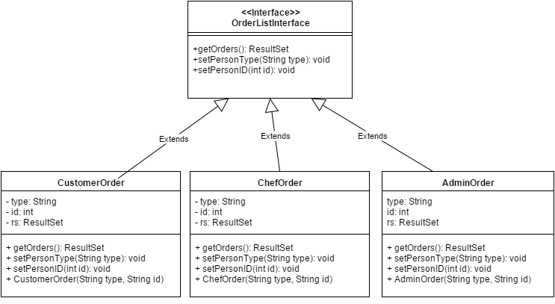

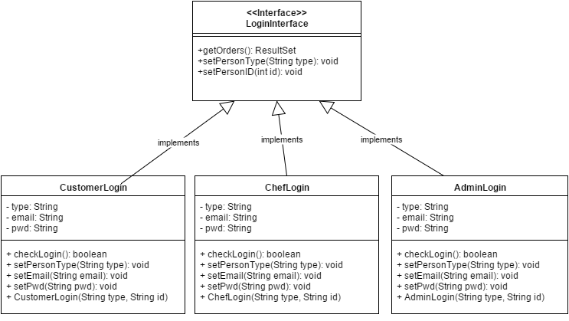

## Software Testing

Testing for this application is done manually. We have done both black box and white box testing related to the different functions in our application. For black box testing we have done JUnit tests using Netbeans 8.1 IDE. The below sample tests include results from both types of testings.

### SAMPLE TESTS

**Test : 1**

**Requirement(s) under test**: RAS_Manager_US_03 : As a Manager, I want to edit the menu items so that I can update the menu, offers/ deals for the day

**Function(s)/Module(s) under test:** MenuPage.java file

**Initial conditions:** Manager is logged into the application

**Assumptions:** None

**Test case input:** Give inputs as given below and click on ADD button

MENU NAME : Andhra Chicken Biryani

MENU TYPE : biryani

DESCRIPTION : Basmathi rice cooked with Natu kodi chicken

PRICE : 15.99

**Expected result:** Given menu details should be added successfully and displayed in the menu page when clicked on DHUM BIRYANI option

**Result:** PASSED

Before clicking on ADD button

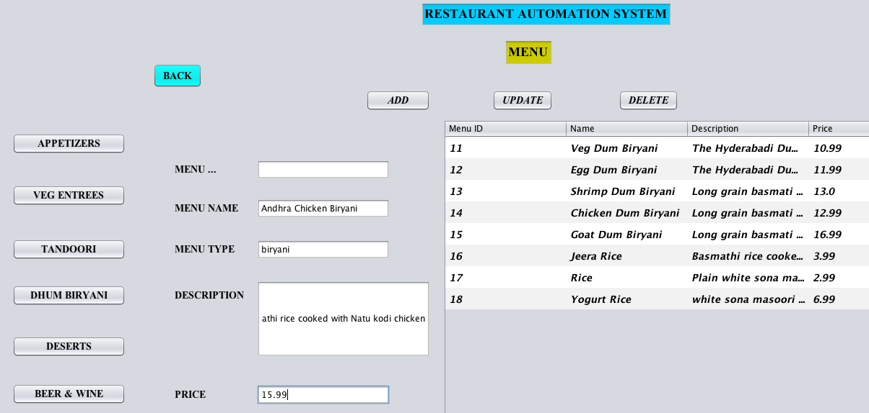

After clicking on ADD button

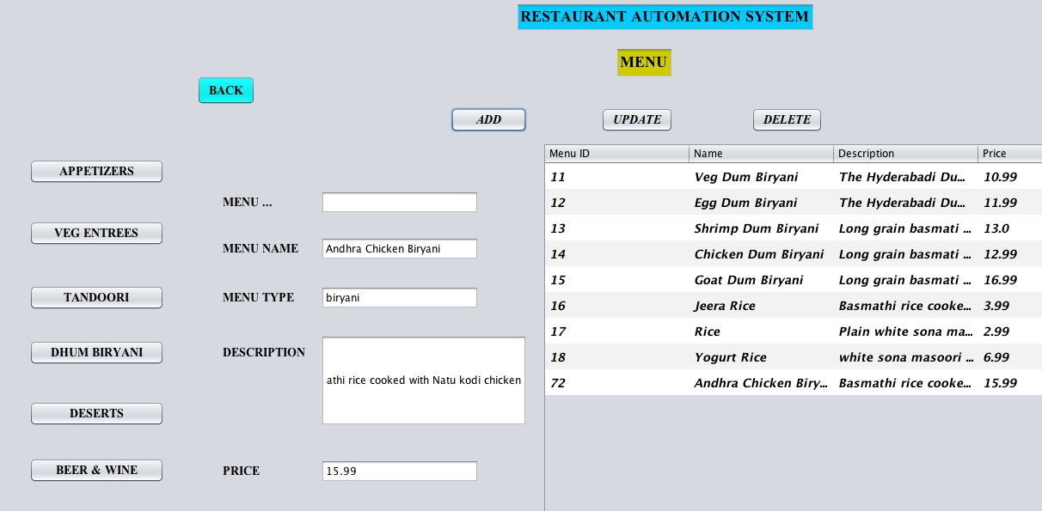

**Test : 2**

**Requirement(s) under test**: RAS_Manager_US_05 : As a Manager, I want to login to the Restaurant Automation system application so that i am able to access the same.

**Function(s)/Module(s) under test:** AdminLoginPage.java file

**Initial conditions:** Manager is not logged into the application

**Assumptions:** None

**Test case input:** Give inputs as given below and click on Login button

User Name : revanth

Password : karthik

**Expected result:** Admin should login successfully

**Result:** PASSED

Admin enters the credentials

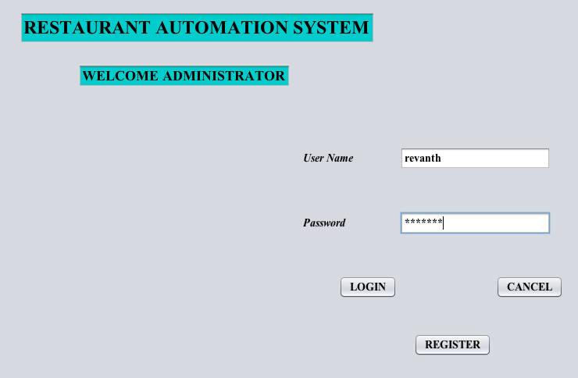

Admin logged in successfully

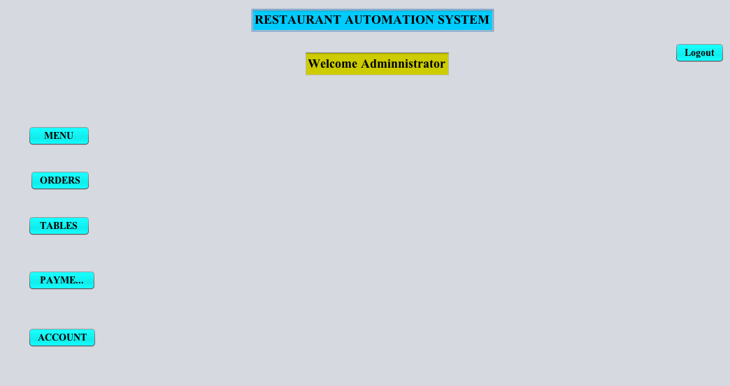

**Test : 3**

**Requirement(s) under test**: RAS_Customer_US_02 : As a Customer, I want to place an order so that I can get the food

**Function(s)/Module(s) under test:** MenuCustomer1.java file

**Initial conditions:** Customer is logged in successfully and in on the Menu page

**Assumptions:** None

**Test case input:** Give inputs as given below and click on SAVE ORDER button

QUANTITY : 1

MENU ID : 3

Again give the below inputs and click on SAVE ORDER button

QUANTITY : 3

MENU ID : 4

Now click on PLACE ORDER button

**Expected result:** Order should be placed successfully

**Result:** PASSED

Customer placing an order

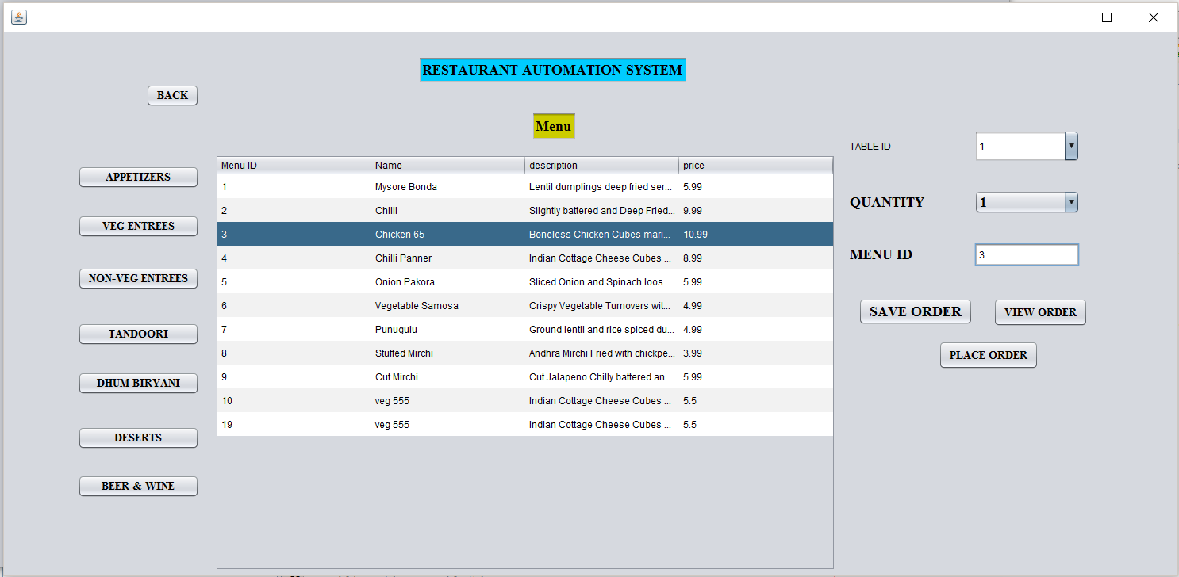

2 items ordered: can be seen on clicking view order

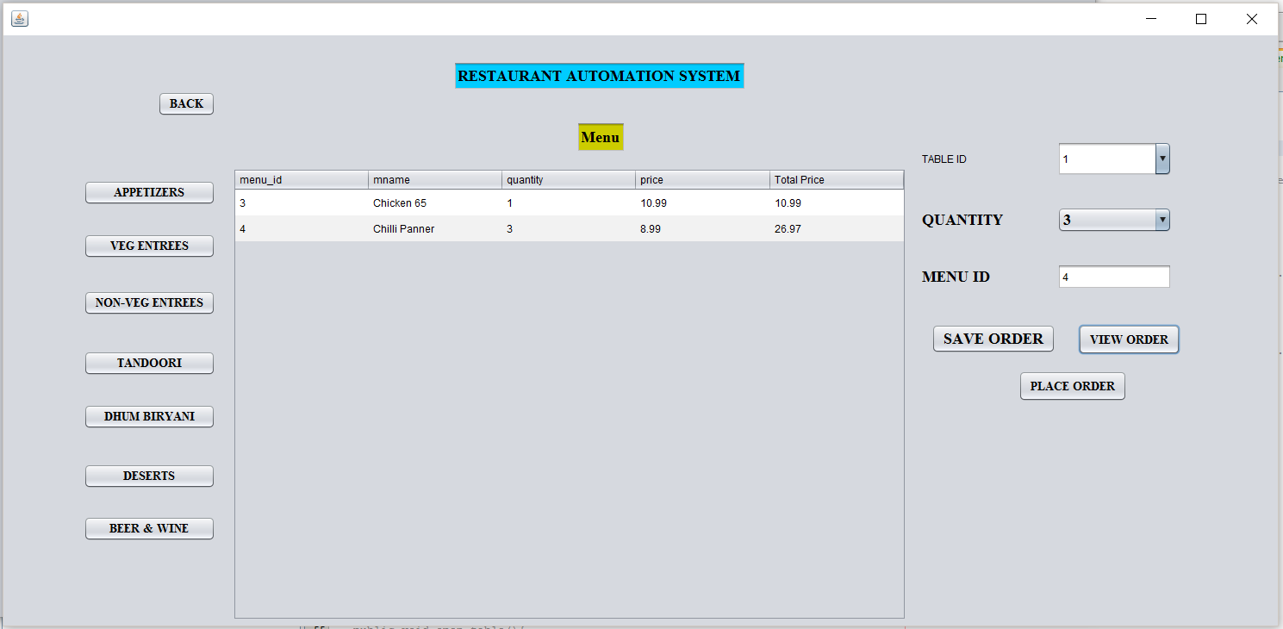

Order placed successfully

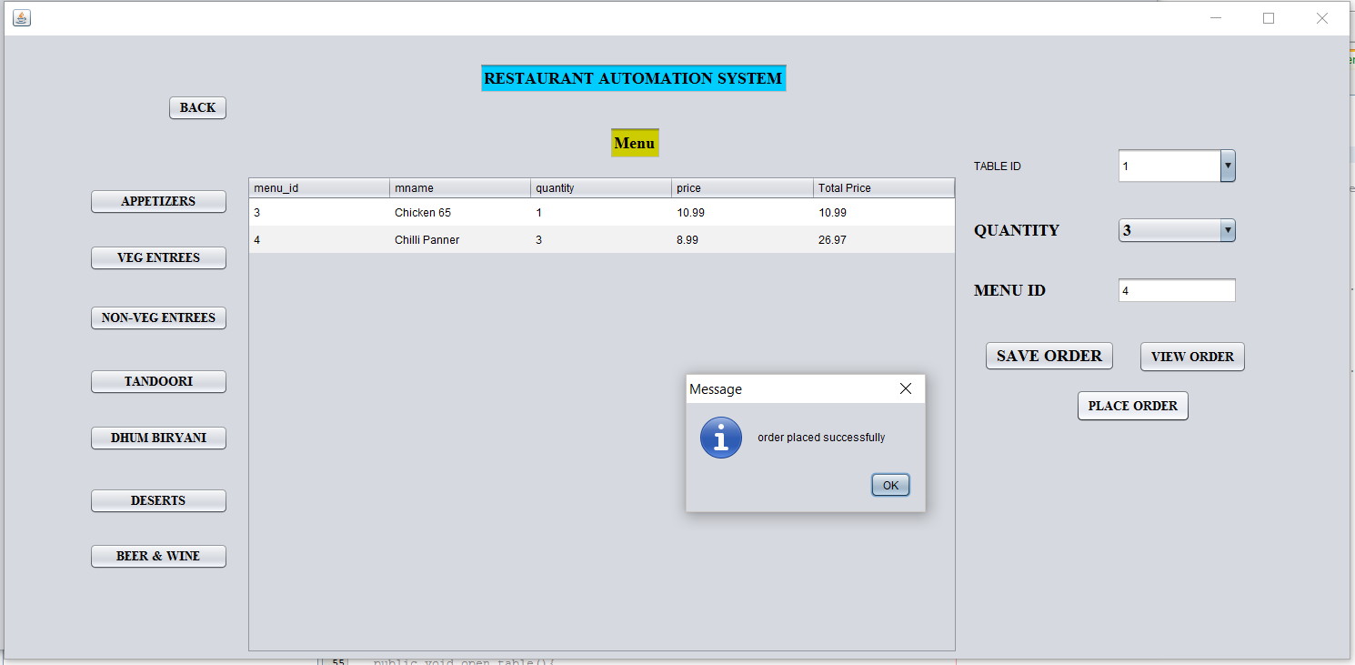

**Test : 4**

**Requirement(s) under test**: RAS_Manager_US_03 : As a Manager, I want to edit the menu items so that I can update the menu, offers/ deals for the day

**Function(s)/Module(s) under test:** MenuPage.java file

**Initial conditions:** Manager is logged into the application

**Assumptions:** None

**Test case input:** Select a menu item from Appetizers and update the fields as below.

MENU NAME : Non veg 555

MENU TYPE : appetizer

Now click on UPDATE button

**Expected result:** Given menu details should be updated successfully and displayed in the menu page when clicked on APPETIZER option

**Result:** PASSED

MANAGER editing the menu

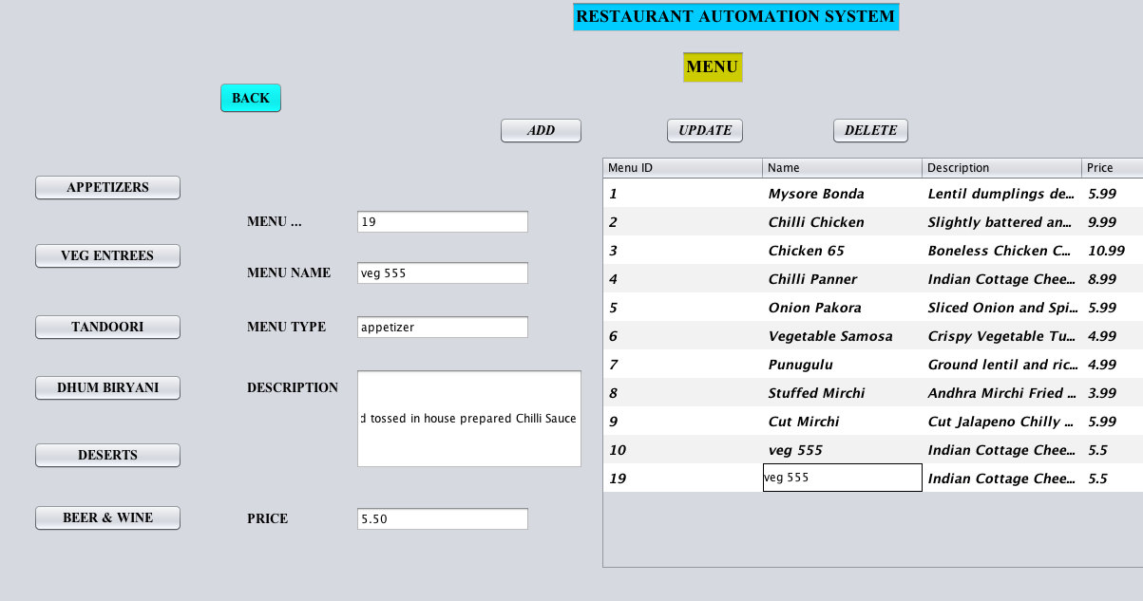

Menu updated successfully

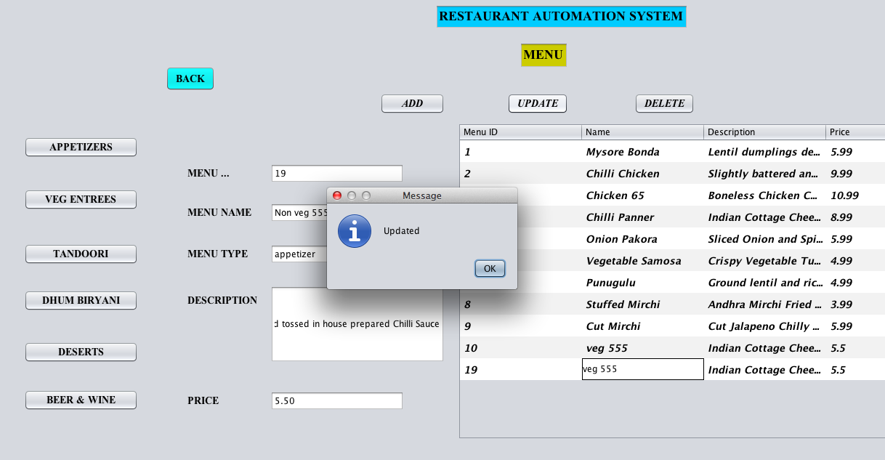

Updated menu displayed on the screen

